Otieco, Juan Gabriel L. 03/12/2019  
2-ECE-B  
Advance ComProg

Experiment 9- Programming Assignment Proof

PROBLEM 1:

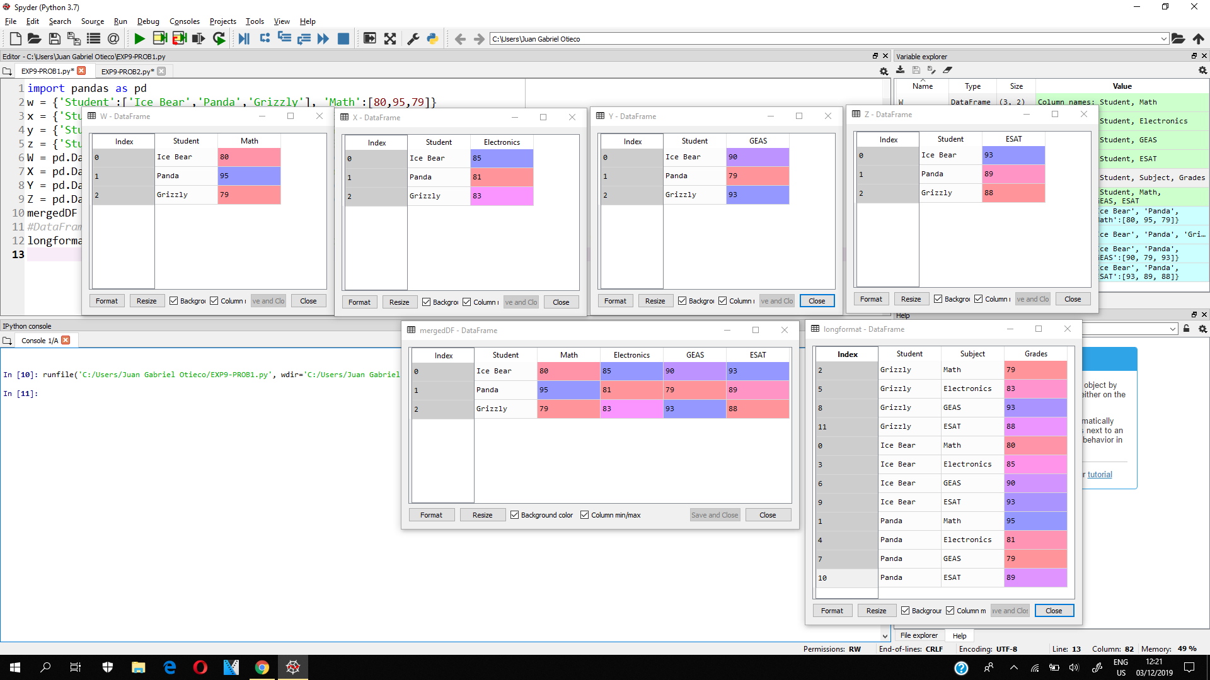



PROBLEM 2:

